Dynamics 365 crm javascript

1) recommended project structure (namespace pattern)
- avoid global variables; always use a namespace and an module pattern.
- keep one entry point per form (onload), then call internal functions.
- export only handlers used by the form or ribbon.
var ns = ns || {};
ns.account = ns.account || {};

ns.account.form = (function () {
"use strict";

function onLoad(executionContext) {
var formContext = executionContext.getFormContext();
// logic
}

function onSave(executionContext) {
var formContext = executionContext.getFormContext();
var eventArgs = executionContext.getEventArgs();
// logic
}

return {
onLoad: onLoad,
onSave: onSave
};
})();

2) core javascript syntaxes (basic to advanced)

2.1 variables and types
- let: This is the preferred way to declare a variable whose value might change. It is block-scoped, which helps prevent issues common with the older var keyword.
let accountName = formContext.getAttribute("name").getValue();
- const: Use this for variables whose value should not be changed after initial assignment (constants). It is also block-scoped and helps ensure data integrity.
const activeStatus = 0;
const entityLogicalName = "account";
- var: This is a function-scoped keyword from older JavaScript versions. It is generally recommended to avoid using var in modern D365 development due to unintuitive behaviors related to scoping and hoisting
Why no var?
Because it Is global scoped of function scoped which may cause problems when used.
For e.g
For loop nested
Used the same variable I declared using var in two different loops loop1- I and loop2 - I then the l2 will not be overridden with l1 I’s value as it is function scoped. This can be resolved using the let keyword
Loop 1 I =10
Loop 2 I =15
Final op => I =10

Declarations -
let a = 10;
const name = 'onkar';
let isActive = true;
let obj = { id: 1 };
let arr = [1, 2, 3];
let n = null;
let u; // undefined

2.2 conditionals and switch
if (a > 5) {
// ...
} else if (a === 5) {
// ...
} else {
// ...
}

switch (status) {
case 1:
break;
case 2:
break;
default:
break;
}

2.3 loops and array helpers
for (let i = 0; i < arr.length; i++) {
// ...
}

for (const x of arr) {
// ...
}

arr.forEach(function (x) { /* ... */ });

const mapped = arr.map(x => x * 2);
const filtered = arr.filter(x => x > 2);
const found = arr.find(x => x === 2);

2.4 functions + try/catch
function add(a, b) { return a + b; }

const add2 = function (a, b) { return a + b; };

const add3 = (a, b) => a + b;

try {
// risky code
} catch (e) {
console.error(e.message);
}

2.5 promises and async/await
function doAsync() {
return new Promise(function (resolve, reject) {
// resolve(value) or reject(error)
});
}

async function run() {
try {
const value = await doAsync();
return value;
} catch (e) {
throw e;
}
}

3) crm form scripting essentials (executioncontext + formcontext) and XRM

3.1 get formcontext (mandatory)
function onLoad(executionContext) {
var formContext = executionContext.getFormContext();
}

3.2 form type (create/update/read-only)
var formType = formContext.ui.getFormType();
// 1 create, 2 updates, 3 read only, 4 disabled, 6 bulk edit

3.3 record id + entity name
var entityName = formContext.data.entity.getEntityName();
var id = formContext.data.entity.getId();
var cleanId = id ? id.replace(/[{}]/g, '') : null;
Think of the hierarchy like this:
├─ WebApi
├─ Navigation
├─ Utility
└─ App
App ,Navigation, WebApi ,Utility is a namespace under the Xrm object that provides helper/utility methods which are not directly related to a specific form or record.
var globalContext = Xrm.Utility.getGlobalContext();
var userId = globalContext.userSettings.userId;
var userName = globalContext.userSettings.userName;

4) attributes (data) syntaxes

4.1 get/set value
var val = formContext.getAttribute('name').getValue();
formContext.getAttribute('name').setValue('abc');

4.2 required level
formContext.getAttribute('emailaddress1'). setRequiredLevel('required');
formContext.getAttribute('emailaddress1'). setRequiredLevel('none');
// 'recommended' is also valid

4.3 submit mode
setSubmitMode in Microsoft Dynamics 365 is a client-side JavaScript method used to control whether a field's data is sent to the server during a save operation. It is primarily used to force the submission of read-only fields or to skip saving specific fields. The syntax is
formContext.getAttribute(attributeName).setSubmitMode(mode)// 'dirty' (default), 'never'

- "always": The data is always sent with a save, even if the value hasn't changed.
- "never": The data is never sent with a save.
- "dirty": (Default) The data is only sent if the value has changed

4.4 dirty checks
var isFormDirty = formContext.data.entity.getIsDirty();
var isFieldDirty = formContext.getAttribute('name').getIsDirty();
- Check if form is dirty to verify if any field on the form has been changed.
Using the function getIsDirty, you can check if any field on the form has been modified.
formContext.data.entity.getIsDirty();
This function will return true if the form is dirty, false otherwise.
- Check if a field is dirty to verify if a specific field on the form has been changed.
formContext.getAttribute("schema-fieldname").getIsDirty();
This function will return true if the field is dirty, false otherwise.
- Display all the modified fields to verify what fields on the form have been changed.
formContext.data.entity.getDataXml();
This function will get the list of attributes that have been modified on the form with the values of each field.
A Xml result having a parent tag and inner elements where the root tag contains the entity logical name and the inner tags contain the fields' logical name with the current value of each field.
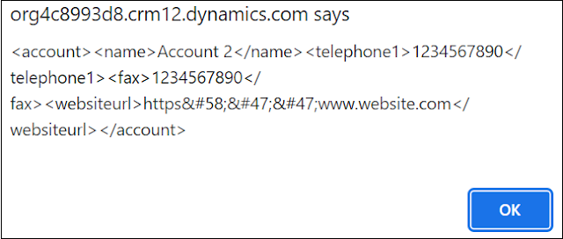

5) controls (Ui) syntaxes

5.1 visible/disabled/focus
formContext.getControl('name').setVisible(false);
formContext.getControl('name').setDisabled(true);
formContext.getControl('name').setFocus();

5.2 tabs and sections
formContext.ui.tabs.get('tab_general').setVisible(true);
formContext.ui.tabs.get('tab_general').sections.get('section_details').setVisible(false);

6) notifications (form + field)

6.1 form notification
formContext.ui.setFormNotification('saved successfully', 'INFO', 'notif_save');
formContext.ui.clearFormNotification('notif_save');

6.2 field notification
formContext.getControl('emailaddress1').setNotification('email is required', 'email_notif');
formContext.getControl('emailaddress1').clearNotification('email_notif');
Use of timeout function-
function DisplayNotification() {
var message = "Useful message to the end user";
var type = "INFO"; //INFO, WARNING, ERROR
var id = "Info1"; //Notification Id
var time = 3000; //Display time in milliseconds
//Display the notification
Xrm.Page.ui.setFormNotification(message, type, id) ;
//Wait the designated time and then remove
setTimeout(
function () {
Xrm.Page.ui.clearFormNotification(id);
},
time
);
}

7) events: onload / onchange / onsave

7.1 add onchange programmatically
formContext.getAttribute('name').addOnChange(ns.account.form.onNameChange);
E.g
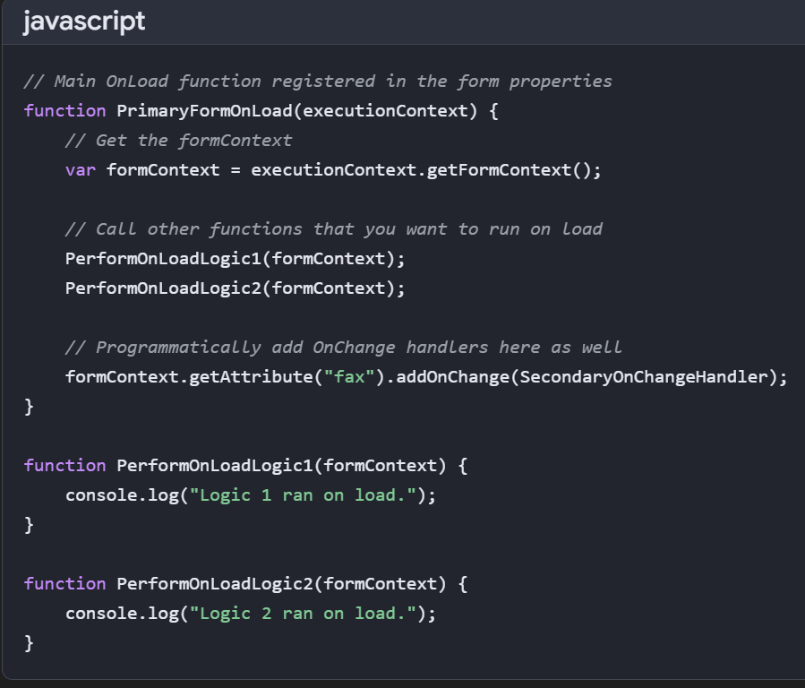
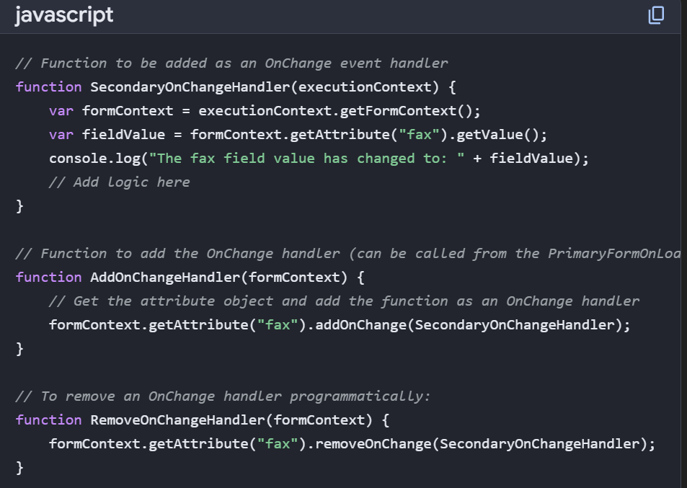

7.2 prevent save (onsave validation)
function onSave(executionContext) {
var formContext = executionContext.getFormContext();
var eventArgs = executionContext.getEventArgs();
- getEventArgs() method returns an object containing methods to manage the event handler, such as preventing the default behavior (e.g., stopping a save operation) or getting specific data related to the event.
var start = formContext.getAttribute('new_startdate').getValue();
var end = formContext.getAttribute('new_enddate').getValue();

if (start && end && end < start) {
eventArgs.preventDefault();
formContext.ui.setFormNotification('end date cannot be before start date', 'ERROR', 'date_err');
} else {
formContext.ui.clearFormNotification('date_err');
}
}

7.3 save mode (often asked)
var saveMode = executionContext.getEventArgs().getSaveMode();
// 1 save, 2 save&close, 59 save&new, 70 autosave

7.4 prevent infinite loops in onchange (pattern)
var ns = ns || {};
ns.flags = ns.flags || { isUpdating: false };

function onAmountChange(executionContext) {
var formContext = executionContext.getFormContext();
if (ns.flags.isUpdating) return;

try {
ns.flags.isUpdating = true;
var amount = formContext.getAttribute('new_amount').getValue() || 0;
formContext.getAttribute('new_total').setValue(amount * 1.18);
formContext.getAttribute('new_total').setSubmitMode('always');
} finally {
ns.flags.isUpdating = false;
}
}

BPF Stage change event -
function onLoad(executionContext) {
var formContext = executionContext.getFormContext();

// Fires after stage changes
formContext.data.process.addOnStageChange(onStageChange);

// Optional: Fires before stage changes
formContext.data.process.addOnPreStageChange(onPreStageChange);
}
function onStageChange(executionContext) {
var formContext = executionContext.getFormContext();

var activeStage = formContext.data.process.getActiveStage();

if (activeStage) {
var stageName = activeStage.getName();
var stageId = activeStage.getId();

console.log("Stage Changed");
console.log("Stage Name: " + stageName);
console.log("Stage Id: " + stageId);

if (stageName === "Qualify") {
// Your custom logic
formContext.getAttribute("description")
?.setValue("Entered Qualify Stage");
}
}
}
Promises vs Callbacks
1. Callback
A callback is a function passed as an argument to another function that executes after an operation completes.
function getData(callback) {
setTimeout(function () {
callback("Data received");
}, 1000);
}

getData(function (result) {
console.log(result);
});

8) field type syntaxes (lookup, option set, two options, multiselect, dates)

8.1 lookup get/set/clear
// get
var l = formContext.getAttribute('parentaccountid').getValue();
if (l && l.length > 0) {
var id = l[0].id.replace(/[{}]/g, '');
var name = l[0].name;
var entityType = l[0].entityType;
}
// set
var value = [{
id: '00000000-0000-0000-0000-000000000001',
name: 'contoso',
entityType: 'account'
}];
formContext.getAttribute('parentaccountid').setValue(value);

// clear
formContext.getAttribute('parentaccountid').setValue(null);

8.2 option set + two options + multiselect
// option set
var osVal = formContext.getAttribute('new_status').getValue(); // number
var osText = formContext.getAttribute('new_status').getText(); // label
formContext.getAttribute('new_status').setValue(100000001);

// two options (boolean)
var flag = formContext.getAttribute('new_approved').getValue(); // true/false
formContext.getAttribute('new_approved').setValue(true);

// multi-select option set
var ms = formContext.getAttribute('new_tags').getValue(); // array of numbers
formContext.getAttribute('new_tags').setValue([100000000, 100000002]);

8.3 date + number calculations
var d1 = formContext.getAttribute('new_start').getValue();
var d2 = formContext.getAttribute('new_end').getValue();

if (d1 && d2 && d2 < d1) {
// invalid
}

if (d1 && d2) {
var diffDays = Math.floor((d2 - d1) / (1000 * 60 * 60 * 24));
formContext.getAttribute('new_duration').setValue(diffDays);
}

var amt = formContext.getAttribute('new_amount').getValue() || 0;
formContext.getAttribute('new_amount').setValue(amt + 100);

9) xrm.webapi (brief + key concepts)
- xrm.webapi is the supported client-side api for dataverse operations from model-driven apps.
- all calls are asynchronous and return promises (use then/catch or async/await).
- security is enforced: results depend on the current user privileges.
- odata query options are used for selecting/filtering data: $select, $filter, $top, $expand.
- lookups are set using @odata.bind in create/update payloads.
- By default, Xrm.WebApi methods like retrieveRecord, createRecord, updateRecord, and deleteRecord are asynchronous. They return promises, allowing your code to continue running while the server processes the request.

9.1 common odata examples (syntax)
// select specific columns
?$select=name,telephone1

// filter
?$select=fullname&$filter=contains(fullname,'on')

// expand related (example)
?$select=name&$expand=primarycontactid($select=fullname,emailaddress1)

10) xrm.webapi syntaxes (crud + lookup binding)

10.1 retrieve record
Xrm.WebApi.retrieveRecord('account', accountId, '?$select=name,telephone1')
.then(function (result) {
console.log(result.name);
})
.catch(function (error) {
console.error(error.message);
});

10.2 retrieve multiple
Xrm.WebApi.retrieveMultipleRecords(
'contact',
"?$select=fullname,emailaddress1&$filter=contains(fullname,'on')&$top=5"
).then(function (res) {
res.entities.forEach(function (e) { console.log(e.fullname); });
}).catch(function (err) { console.error(err.message); });

Use of expand in multiple retrieval
Xrm.WebApi.retrieveMultipleRecords(
"account",
"?$select=name" +
"&$expand=primarycontactid($select=fullname)"
).then(function (result) {
console.log(result.entities); // each entity has primarycontactid object populated
});

10.3 create record
var data = { name: 'new account' };

Xrm.WebApi.createRecord('account', data)
.then(function (res) {
console.log(res.id);
})
.catch(function (err) {
console.error(err.message);
});

10.4 update record
var data = { telephone1: '9999999999' };

Xrm.WebApi.updateRecord('account', accountId, data)
.then(function () { })
.catch(function (err) { console.error(err.message); });

10.5 delete record
Xrm.WebApi.deleteRecord('account', accountId)
.then(function () { })
.catch(function (err) { console.error(err.message); });

Operators in webapi
- $select: Specifies the columns (attributes) to return.
- $filter: Filters the results based on specific criteria using logical and comparison operators.
- $orderby: Sorts the results by a specific column in asc (ascending) or desc (descending) order.
- $top: Limits the number of records returned to the top n results.
- $expand: Includes related entity records in the results (e.g., retrieving an account's primary contact details)

10.6 set lookup using @odata.bind
var data = {
'parentaccountid@odata.bind': '/accounts(' + accountId + ')'
};

Xrm.WebApi.updateRecord('contact', contactId, data);

10.7 progress indicator pattern (always close in finally)
async function loadAccountData(executionContext) {
var formContext = executionContext.getFormContext();
var acc = formContext.getAttribute('parentaccountid').getValue();
if (!acc) return;

var accId = acc[0].id.replace(/[{}]/g, '');

try {
Xrm.Utility.showProgressIndicator('loading...');
const res = await Xrm.WebApi.retrieveRecord('account', accId, '?$select=telephone1');
formContext.getAttribute('telephone1').setValue(res.telephone1);
} catch (e) {
Xrm.Navigation.openAlertDialog({ text: e.message });
} finally {
Xrm.Utility.closeProgressIndicator();
}}

11) ribbon command syntaxes (primarycontrol)
- ribbon command javascript usually receives primarycontrol instead of executioncontext.
- treat primarycontrol as formcontext.
function onRibbonClick(primaryControl) {
var formContext = primaryControl;
var id = formContext.data.entity.getId();
var cleanId = id ? id.replace(/[{}]/g, '') : null;

Xrm.Navigation.openAlertDialog({ text: 'clicked' });
}

11.1 open related record after create (pattern)
async function createInvoiceAndOpen(primaryControl) {
var formContext = primaryControl;
var woId = formContext.data.entity.getId().replace(/[{}]/g, '');

var payload = {
name: 'invoice from ribbon',
'new_workorder@odata.bind': '/msdyn_workorders(' + woId + ')'
};

const res = await Xrm.WebApi.createRecord('invoice', payload);

await Xrm.Navigation.openForm({
entityName: 'invoice',
entityId: res.id
});
}

12) bpf (business process flow) syntaxes

12.1 get active stage
var stage = formContext.data.process.getActiveStage();
if (stage) {
var stageName = stage.getName();
var stageId = stage.getId();
}

12.2 add stage change handler
formContext.data.process.addOnStageChange(function (ctx) {
var formContext = ctx.getFormContext();
// logic
});

12.3 set active stage
formContext.data.process.setActiveStage(stageId, function (result) {
// result = 'success' or 'fail'
});

13) lookup filtering (addpresearch + addcustomfilter)
function applyContactFilter(executionContext) {
var formContext = executionContext.getFormContext();
var ctrl = formContext.getControl('primarycontactid');

if (!ctrl) return;

ctrl.addPreSearch(function () {
var account = formContext.getAttribute('parentaccountid').getValue();
if (!account) return;

var accountId = account[0].id.replace(/[{}]/g, '');

var filterXml =
"<filter type='and'>" +
"<condition attribute='parentcustomerid' operator='eq' value='" + accountId + "' />" +
"</filter>";

ctrl.addCustomFilter(filterXml, 'contact');
});
}

14) refresh syntaxes (form, ribbon, sub grid)
// refresh form data (does not save)
formContext.data.refresh(false);

// save
formContext.data.save();

//save and refresh
Formcontext.data.refresh(true);

// refresh ribbon
formContext.ui.refreshRibbon();

// refresh subgrid
formContext.getControl('Contacts').refresh();
Difference -
Use formContext.data.refresh() when:
- Data changed (from plugin / Power Automate / popup)
- You want refreshed fields
- You want Onload to re-trigger
- You want server-side values pulled again
[bing.com]
Use formContext.ui.refreshRibbon() when:
- A ribbon button should enable/disable
- A ribbon button should show/hide
- Command bar logic depends on a field that changed

Async And await –
Async and await are modern JavaScript keywords used to handle asynchronous operations (tasks that take time, like data fetching) in a way that looks and behaves like synchronous code. They prevent "callback hell" and make code easier to read and maintain.
- async: Placed before a function declaration, it ensures the function returns a Promise.
- await: Placed before a Promise-returning call, it pauses the execution of the async function until the Promise is resolved or rejected.
Example in MS D365 CRM (JavaScript)
In D365 CRM, you often need to fetch data using Xrm.WebApi without freezing the user interface. Using async/await is the recommended way to handle these non-blocking calls.
Scenario: Fetch a contact's telephone number when a form loads, and alert it.
javascript
// Function registered on Form OnLoad
async function getContactPhone(executionContext) {
let formContext = executionContext.getFormContext();

// Get the current record ID
let contactId = formContext.data.entity.getId().replace(/[{}]/g, "");

if (contactId) {
try {
// Await: Pauses here until the data is retrieved
let result = await Xrm.WebApi.retrieveRecord("contact", contactId, "?$select=telephone1");

// This line executes only after the data is received
if (result.telephone1) {
console.log("Phone: " + result.telephone1);
formContext.getControl("telephone1").setNotification("Fetched: " + result.telephone1, "phone");
}
} catch (error) {
// Error handling if retrieval fails
console.error("Error retrieving phone: " + error.message);
}
}
}

Key Takeaways from the Example
- async function: The function is marked async, allowing it to return a Promise and use await inside.
- await Xrm.WebApi...: The code waits for Xrm.WebApi to finish without blocking the entire browser (the UI remains responsive).
- try...catch: A standard JavaScript try...catch block handles errors, making the code much cleaner than traditional. then().catch() chains.
What is promise?
A Promise is an object representing the eventual completion (or failure) of an asynchronous operation. It provides a cleaner way to handle asynchronous operations compared to traditional callback functions, helping to avoid "callback hell."
Key Characteristics of Promises
- States: A Promise can be in one of three states.
  - Pending: Initial state, neither fulfilled nor rejected.
  - Fulfilled: Operation completed successfully.
  - Rejected: Operation failed.
- Methods:
  - then(): Executes when the Promise is fulfilled.
  - catch(): Executes when the Promise is rejected.
  - finally(): Executes regardless of the Promise's outcome
- Resolved Promise: Use the. then() method
- Rejected Promise: Use the. catch() method
- Regardless of Outcome: Use. finally () to execute code after handling the Promise.
E. gDuring database server data retrieval, a Promise remains pending until successful data reception (resolved state) or unsuccessful retrieval (rejected state).
const promise = new Promise(function (resolve, reject) {
const string1 = "geeksforgeeks";
const string2 = "geeksforgeeks";
if (string1 === string2) {
resolve();
} else {
reject();
}
});

promise
.then(function () {
console.log("Promise resolved successfully");
})
.catch(function () {
console.log("Promise is rejected");
});

Difference between Execution context & Form context –
In Dynamics 365 CRM, the executionContext is an object passed to a JavaScript function that provides information about the event that triggered it, while the formContext is derived from it to interact with form fields, tabs, and controls. Think of execution context as the trigger (e.g., OnLoad) and form context as the form itself

In Dynamics 365 CRM:
✔ Logical Name
- Used in formContext, attributes, controls, Web API.
- Appears in the Field properties → “Name”.
- Lowercase with underscores → new_customfield.
✔ Schema Name
- Used only in:
  - Plugins (C#)
  - Workflows
  - Solution XML
- Usually PascalCase → new_CustomField.
- formContext.ui.setFormNotification("saved successfully", "INFO", "notif_save");
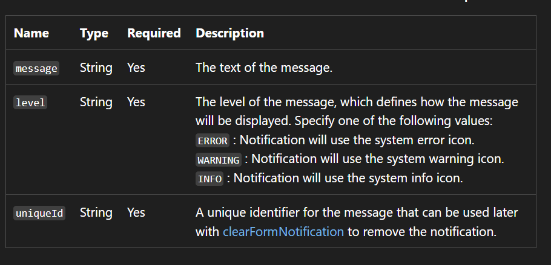

- getEventArgs is a method in Microsoft Dynamics 365/Dataverse client-side scripting (JavaScript) used to retrieve an object containing details about the current event, such as save modes or preventing actions.

Xrm is the client-side JavaScript namespace provided by Microsoft Dynamics 365 (model-driven apps).
It is the root object for all supported client APIs used in:
- Form scripting
- Ribbon commands
- Business rules (JS)
- PCF components
- Web API calls
- Navigation & dialogs

✔ 2. Xrm.Utility
a client-side JavaScript namespace that provides a container for useful, reusable functions that are not directly tied to a specific form or page.manage data outside of the current form context

Used for common utility actions:
Xrm.Utility.showProgressIndicator("loading...");
Xrm.Utility.closeProgressIndicator();
Xrm.Utility.openWebResource("new_/page.html");

3.. Xrm.Navigation
Dialogs + navigate actions:
Xrm.Navigation.openAlertDialog({ text: "done" });
Xrm.Navigation.openConfirmDialog({ text: "proceed?" });
Xrm.Navigation.openForm({ entityName: "account" });
navigateTo(pageInput, navigationOptions) -This is a core method used to navigate to different types of pages, including entity lists, records, HTML web resources, or custom pages.
e.g- var pageInput = {
pageType: "entityrecord",
entityName: "account",
entityId: "00aa00aa-bb11-cc22-dd33-44ee44ee44ee" // Replace with actual GUID
};

var navigationOptions = {
target: 2, // 2 opens in a dialog; 1 opens inline
height: { value: 80, unit: "%" },
width: { value: 70, unit: "%" },
position: 1 // 1 is center; 2 is side pane
};

Xrm.Navigation.navigateTo(pageInput, navigationOptions).then(
function success() {
console.log("Record opened successfully.");
},

//open url
openUrl(url, openWindowOptions)

4. Xrm.WebApi
Client-side Web API (CRUD/LIST/FETCH):

Xrm.WebApi.retrieveRecord("account", id, "?$select=name");
Xrm.WebApi.createRecord("contact", data);

5.What is Web API in Dynamics 365 CRM?
Web API is the official, modern, RESTful API provided by Microsoft Dynamics 365 / Dataverse that allows you to perform CRUD operations (Create, Read, Update, Delete) and complex data operations over HTTP.
It is:
- REST-based
- JSON formatted
- Secure (uses OAuth tokens)
- Works from JavaScript, Plugins, Power Automate, External apps, Portals, Azure Functions
- Preferred over Organization Service (SOAP

What is Web API in Dynamics 365 CRM?
Web API is the official, modern, RESTful API provided by Microsoft Dynamics 365 / Dataverse that allows you to perform CRUD operations (Create, Read, Update, Delete) and complex data operations over HTTP.
It is:
- REST-based
- JSON formatted
- Secure (uses OAuth tokens)
- Works from JavaScript, Plugins, Power Automate, External apps, Portals, Azure Functions
- Preferred over Organization Service (SOAP)

🎯 Simple definition (use this in interview)
“Web API is the REST API of Dataverse that lets you interact with CRM data using HTTP methods (GET, POST, PATCH, DELETE) with JSON payloads. It is the modern and recommended way to perform CRUD operations from JavaScript, custom apps, and integrations.”

📌 Why Web API exists (very important)
- Xrm.Page is deprecated
- OrganizationService (SOAP) is legacy
- CRM needed a platform-independent API
- Web API works with:
  - JS in forms
  - Mobile apps
  - External systems
  - Power Automate custom calls
  - Plugins/Custom APIs
  - Azure

🛠️ What Web API can do
✔ CRUD Operations
- Create record
- Retrieve record(s)
- Update record
- Delete record
✔ Fetch related records
✔ Execute bound/unbound actions
✔ Associate / disassociate records
✔ Use OData queries ($select, $filter, $expand, $orderby)
✔ Trigger Custom APIs
✔ Call functions and actions like:
- WinOpportunity
- QualifyLead
- Assign
- SetState

🧠 How Web API works
Operations correspond to HTTP verbs:
Operation | HTTP Verb | Example
Create | POST | /api/data/v9.2/accounts
Retrieve | GET | /api/data/v9.2/accounts(<id>)
Update | PATCH | /api/data/v9.2/accounts(<id>)
Delete | DELETE | /api/data/v9.2/accounts(<id>)
Everything returns JSON.

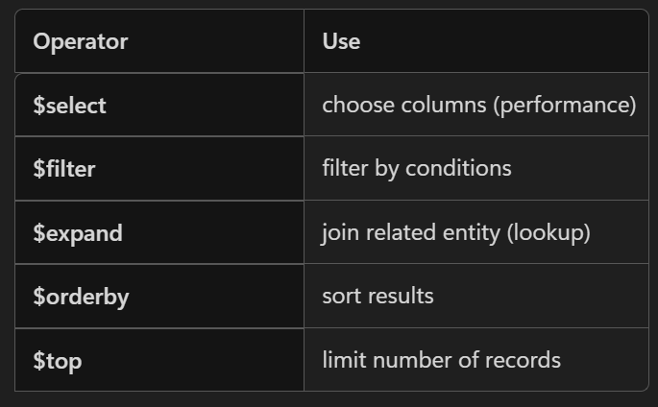

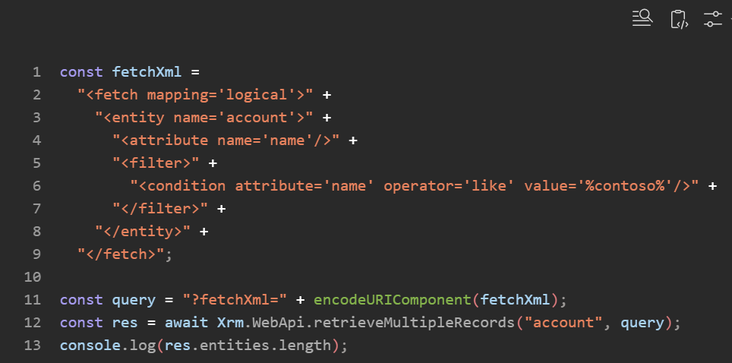
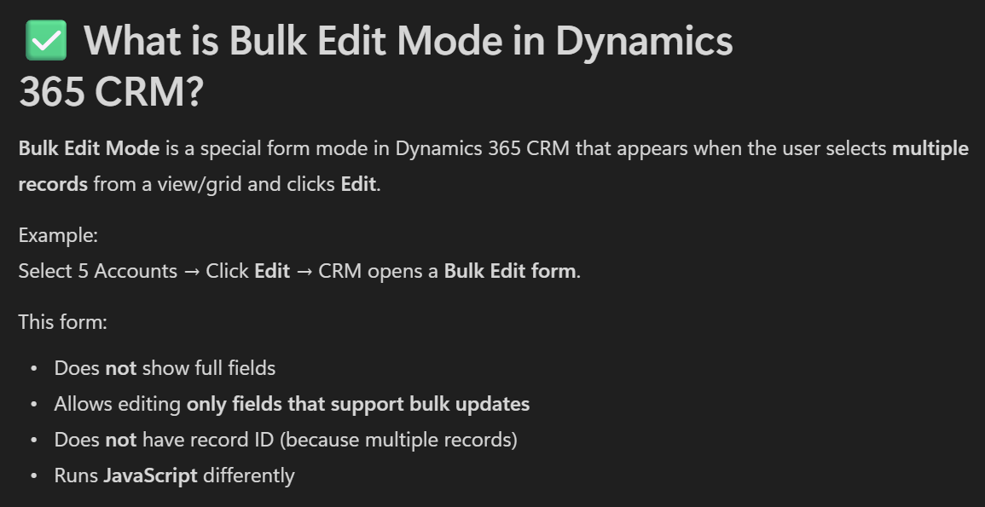

Q. “How do you prevent your JavaScript from running in Bulk Edit mode?”
Answer:
JavaScript
if (formContext.ui.getFormType() === 6) {
return; // bulk edit → skip script
}

Event handlers’ example –
on change of field A setup field b on change of filed b setup field c on change of c setup d - Is it possible using js
var ns = ns || {};
ns.chain2 = (function () {
"use strict";

function onAChange(executionContext) {
var formContext = executionContext.getFormContext();

var a = formContext.getAttribute("new_a")?.getValue();
if (a == null) return;

var bAttr = formContext.getAttribute("new_b");
if (!bAttr) return;

var newB = a * 2;
if (bAttr.getValue() !== newB) bAttr.setValue(newB); // triggers B onchange
}

function onBChange(executionContext) {
var formContext = executionContext.getFormContext();

var b = formContext.getAttribute("new_b")?.getValue();
if (b == null) return;

var cAttr = formContext.getAttribute("new_c");
if (!cAttr) return;

var newC = b + 10;
if (cAttr.getValue() !== newC) cAttr.setValue(newC); // triggers C onchange
}

function onCChange(executionContext) {
var formContext = executionContext.getFormContext();

var c = formContext.getAttribute("new_c")?.getValue();
if (c == null) return;

var dAttr = formContext.getAttribute("new_d");
if (!dAttr) return;

var newD = "VAL-" + c;
if (dAttr.getValue() !== newD) dAttr.setValue(newD);
}

return {
onAChange: onAChange,
onBChange: onBChange,
onCChange: onCChange
};
})();
Add event hanlders on load for a webresource
OR
Also
// Namespace pattern to avoid globals
var MyChain = (function () {

// simple guard to prevent re-entrancy
let _isProgrammatic = false;

function onLoad(executionContext) {
const fc = executionContext.getFormContext();

fc.getAttribute("new_fielda").addOnChange(onAChange);
fc.getAttribute("new_fieldb").addOnChange(onBChange);
fc.getAttribute("new_fieldc").addOnChange(onCChange);
fc.getAttribute("new_fieldd").addOnChange(onDChange); // optional if D has logic
}

function onAChange(executionContext) {
const fc = executionContext.getFormContext();
if (_isProgrammatic) return;

const a = fc.getAttribute("new_fielda").getValue();

// ---- Your logic to compute B from A ----
const bValue = computeBFromA(a);

// Set B and fire its change to continue the chain
_isProgrammatic = true;
fc.getAttribute("new_fieldb").setValue(bValue);
fc.getAttribute("new_fieldb").fireOnChange();
_isProgrammatic = false;
}

function onBChange(executionContext) {
const fc = executionContext.getFormContext();
if (_isProgrammatic) return;

const b = fc.getAttribute("new_fieldb").getValue();

// ---- Your logic to compute C from B ----
const cValue = computeCFromB(b);

_isProgrammatic = true;
fc.getAttribute("new_fieldc").setValue(cValue);
fc.getAttribute("new_fieldc").fireOnChange();
_isProgrammatic = false;
}

function onCChange(executionContext) {
const fc = executionContext.getFormContext();
if (_isProgrammatic) return;

const c = fc.getAttribute("new_fieldc").getValue();

// ---- Your logic to compute D from C ----
const dValue = computeDFromC(c);

_isProgrammatic = true;
fc.getAttribute("new_fieldd").setValue(dValue);
fc.getAttribute("new_fieldd").fireOnChange(); // only if D has downstream logic
_isProgrammatic = false;
}

function onDChange(executionContext) {
const fc = executionContext.getFormContext();
if (_isProgrammatic) return;

// Optional: final validations/UI changes etc. for D
}

// --- Helpers: replace with your own business logic ---
function computeBFromA(a) {
// Example: copy or transform
return a ? a + " → B" : null;
}
function computeCFromB(b) {
return b ? b + " → C" : null;
}
function computeDFromC(c) {
return c ? c + " → D" : null;
}

return {
onLoad,
onAChange,
onBChange,
onCChange,
onDChange
};
})();

Q. how to disable multiple fields –
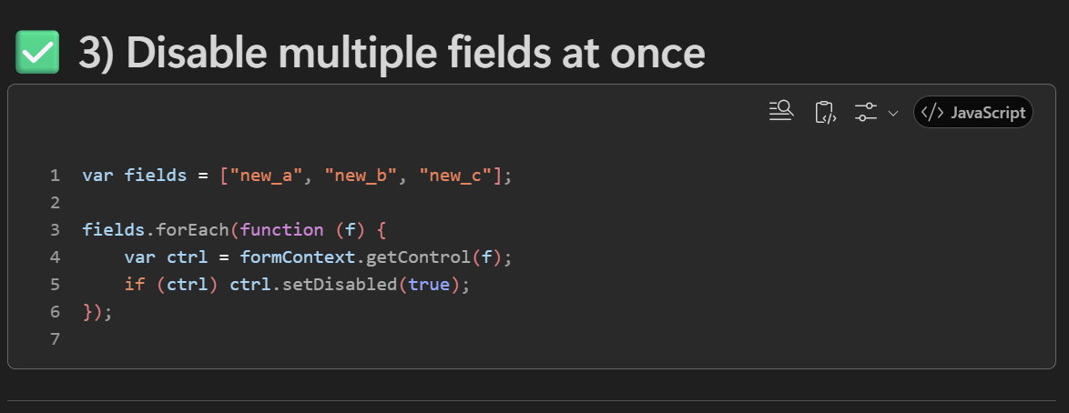

How to disable all the fields in msd 365 crm using the javascript

✅ 1) Get ALL controls on the form
You can access every UI control (field, subgrid, quick view, web resource, etc.) using:
JavaScript
formContext.ui.controls.forEach(function (control) {
console.log(control.getName());
});
Show more lines
What these returns:
- Text fields
- Number fields
- Lookups
- Date fields
- Option sets
- Multi-select
- Subgrids
- Quick view forms
- Web resources
- Timeline
- BPF controls
EVERYTHING that is a control on the form.

✅ 2) Get ALL field controls (only data fields)
If you want only controls that correspond to fields (attributes), use this:
JavaScript
formContext.data.entity.attributes.forEach(function (attribute) {
attribute.controls.forEach(function (control) {
console.log(control.getName());
});
});
Show more lines
This excludes:
- subgrids
- web resources
- quick views
- timeline
- sections
- tabs
Only field UI controls appear here.

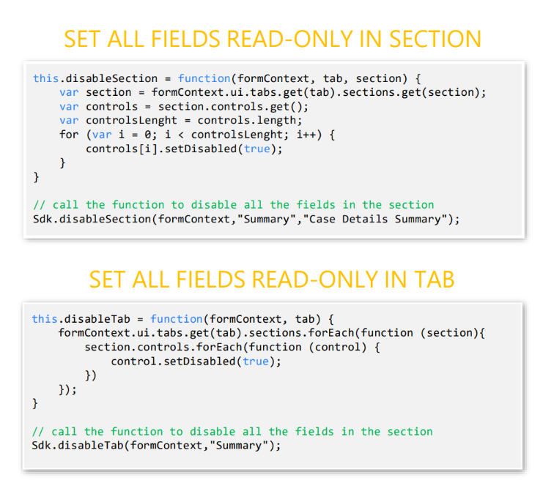
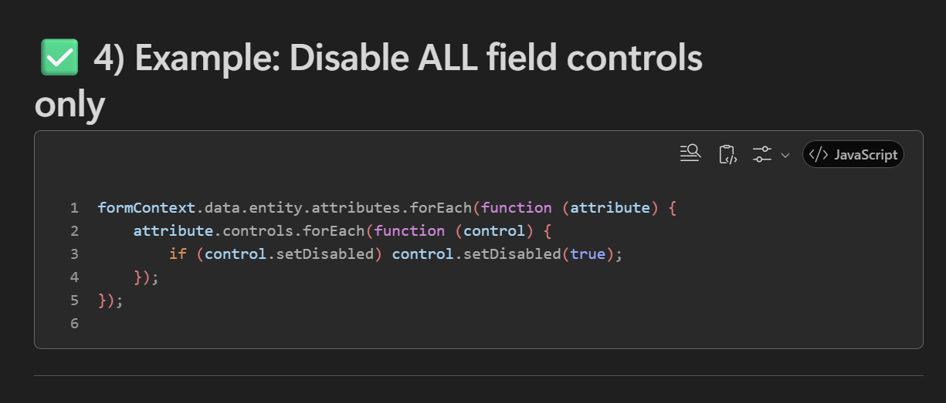
forEach requires a callback—a function that it will call once per item.
That callback receives the current item (e.g., control) and optionally the index and the array.

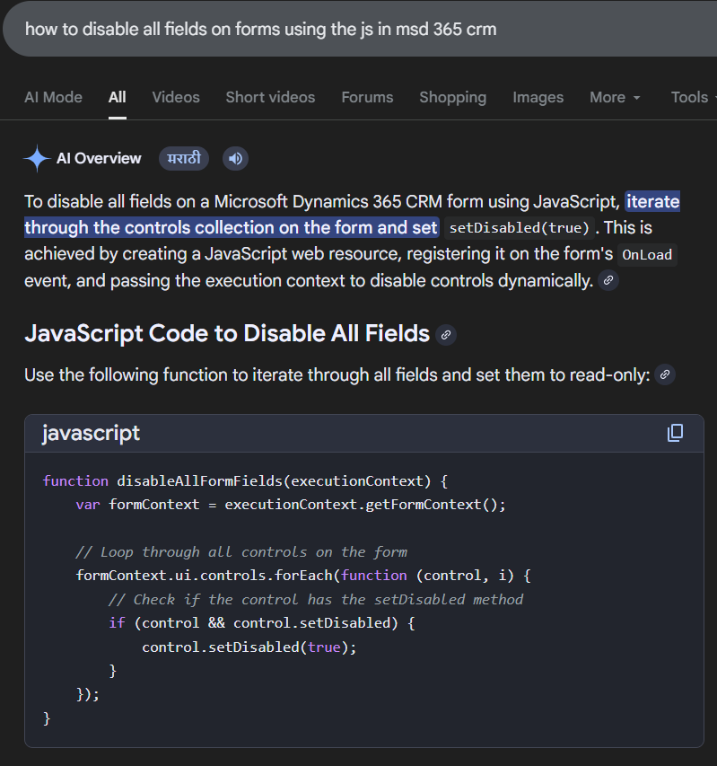

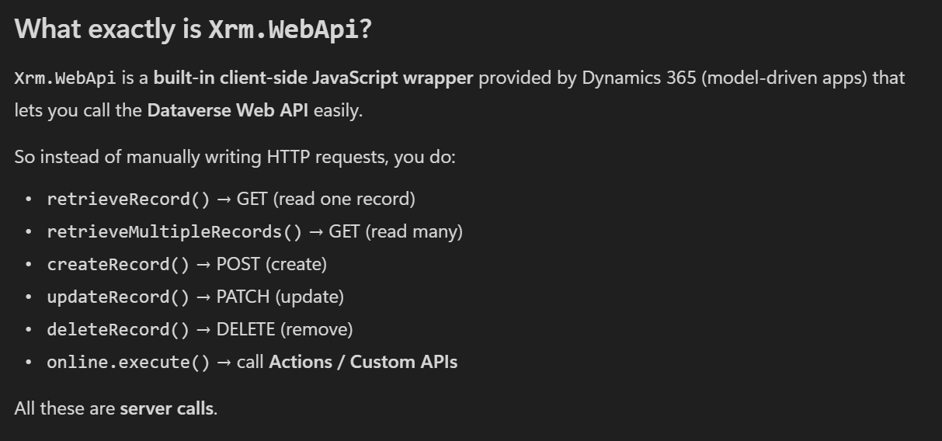
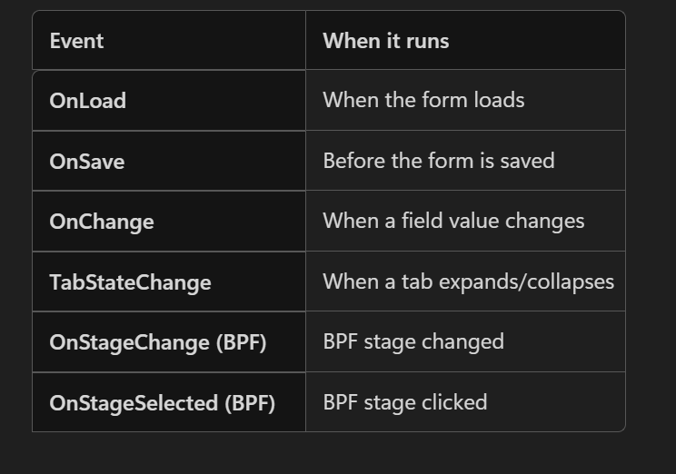
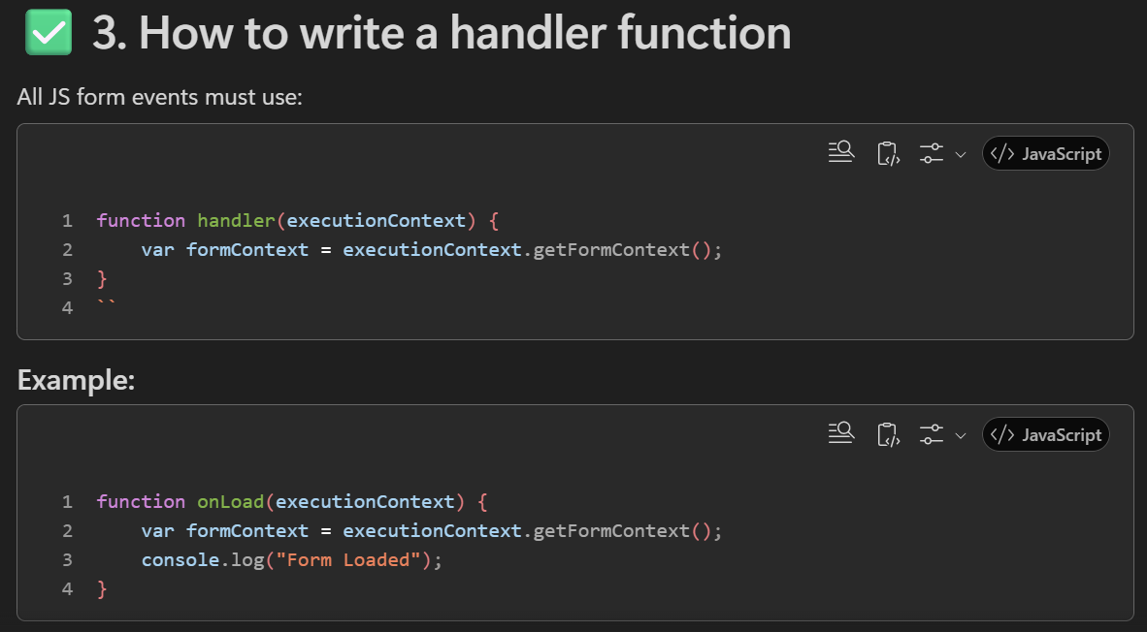

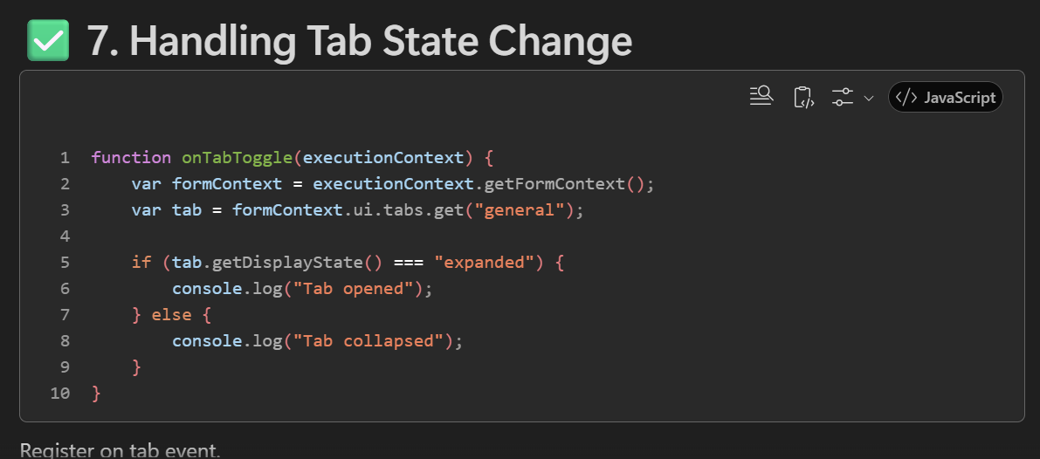
How to debug a JavaScript –
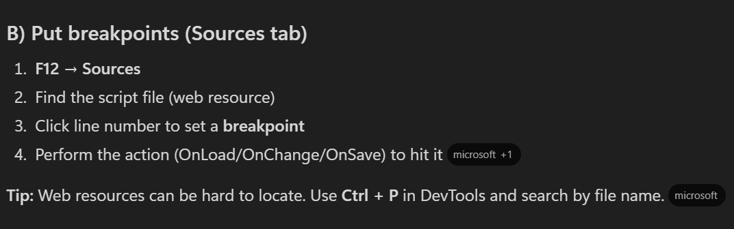
2. use debugger -
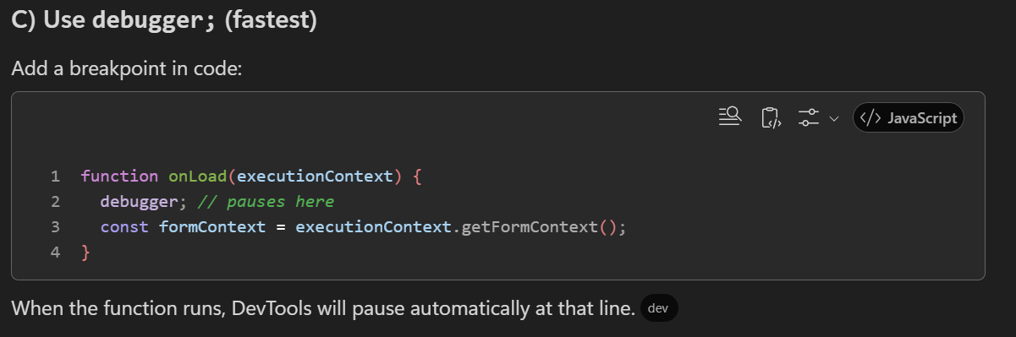
. Create the Action in CRM
- Go to Processes → New → Action
- Select table (for Bound Action) OR choose None (global) for Unbound Action
- Add Input parameters
- Add Output parameters (if needed)
- Add steps (Custom logic / Workflow steps)
- Activate the Action

2. Note the Action Logical Name
- Example: new_MyAction
You will use this name in JavaScript.

3. Prepare the JavaScript Function
- Decide if you want
  - Xrm.WebApi.online.execute() (recommended)
  - or fetch / XMLHttpRequest

4. Build the Request Object
- Set parameters
- Set operationName
- Set operationType = 0
- Set parameterTypes
For Bound Action, include:
- entity: { entityType: "account", id: guid }
- boundParameter: "entity"
For Unbound Action, set:
- boundParameter: null

5. Execute the Action
Use:
JavaScript
Xrm.WebApi.online.execute(request);
Show more lines

6. Handle the Response
- Check if response.ok is true
- If Action returns output → do response.json()
- Use returned values on the form
- Show success/alert dialog if needed
What is an Unbound Action?
An Unbound Action is an Action that is not attached to any table.
✔ Key Points
- Works globally (not tied to a single table).

Bound Action
An Action linked to a specific table that requires the record ID to be executed.

15) common mistakes (interview + real project)
- using xrm.page (deprecated) instead of executioncontext.getformcontext().
- not checking attribute/control exists (shared library breaks on forms where field is missing).
- forgetting to remove { } from guid when building filters or odata bind.
- calling addpresearch repeatedly (duplicate filters) because handler is added multiple times.
- infinite loop in onchange when setvalue triggers the same onchange again.
- not using setsubmitmode('always') for calculated fields that must be saved.
- closing progress indicator only on success; not in finally (loader stuck on error).
- running heavy web api calls on every onchange; should debounce/cache or call only when needed.
- assuming lookup getvalue returns a single object; it returns an array.
- using gettext() where getvalue() is required (optionsets).
- subgrid refresh onload fails because grid is not ready; must wait or use onload of grid.
- not handling autosave save mode (70) leading to unexpected preventdefault behavior.
- hardcoding environment urls or org-specific ids inside scripts.
- not handling promise errors (missing catch) causing unhandled rejection and silent failures.
- using dom manipulation/document access in model-driven apps (unsupported/unstable).

16) quick interview checklist (what to revise fast)
- executioncontext vs primarycontrol (ribbon).
- attributes vs controls (data vs ui).
- onsave validation + save modes + preventdefault.
- lookup get/set/clear + guid cleaning.
- xrm.webapi crud + odata query options + @odata.bind.
- lookup filtering (addpresearch + addcustomfilter).
- bpf get active stage + stage change events + set active stage.
- progress indicator + async/await + finally.
- refresh patterns: form, ribbon, subgrid.

dynamics 365 crm javascript interview syntax notes (form scripting + xrm.webapi + ribbon + bpf)
this document is a consolidated cheat sheet of the most-used javascript syntaxes and patterns for dynamics 365 crm (model-driven apps). it focuses on form scripting, xrm.webapi, ribbon commands, and business process flow (bpf).

1) recommended project structure (namespace pattern)
avoid global variables; always use a namespace and an iife module pattern.
keep one entry point per form (onload), then call internal functions.
export only handlers used by the form or ribbon.
var ns = ns || {};
ns.account = ns.account || {};

ns.account.form = (function () {
"use strict";

function onLoad(executionContext) {
var formContext = executionContext.getFormContext();
// logic
}

function onSave(executionContext) {
var formContext = executionContext.getFormContext();
var eventArgs = executionContext.getEventArgs();
// logic
}

return {
onLoad: onLoad,
onSave: onSave
};
})();

2) core javascript syntaxes (basic to advanced)
2.1 variables and types
let a = 10;
const name = 'onkar';
let isActive = true;
let obj = { id: 1 };
let arr = [1, 2, 3];
let n = null;
let u; // undefined
2.2 conditionals and switch
if (a > 5) {
// ...
} else if (a === 5) {
// ...
} else {
// ...
}

switch (status) {
case 1:
break;
case 2:
break;
default:
break;
}
2.3 loops and array helpers
for (let i = 0; i < arr.length; i++) {
// ...
}

for (const x of arr) {
// ...
}

arr.forEach(function (x) { /* ... */ });

const mapped = arr.map(x => x * 2);
const filtered = arr.filter(x => x > 2);
const found = arr.find(x => x === 2);
2.4 functions + try/catch
function add(a, b) { return a + b; }

const add2 = function (a, b) { return a + b; };

const add3 = (a, b) => a + b;

try {
// risky code
} catch (e) {
console.error(e.message);
}
2.5 promises and async/await
function doAsync() {
return new Promise(function (resolve, reject) {
// resolve(value) or reject(error)
});
}

async function run() {
try {
const value = await doAsync();
return value;
} catch (e) {
throw e;
}
}

3) crm form scripting essentials (executioncontext + formcontext)
3.1 get formcontext (mandatory)
function onLoad(executionContext) {
var formContext = executionContext.getFormContext();
}
3.2 form type (create/update/read-only)
var formType = formContext.ui.getFormType();
// 1 create, 2 update, 3 read only, 4 disabled, 6 bulk edit
3.3 record id + entity name
var entityName = formContext.data.entity.getEntityName();
var id = formContext.data.entity.getId();
var cleanId = id ? id.replace(/[{}]/g, '') : null;

4) attributes (data) syntaxes
4.1 get/set value
var val = formContext.getAttribute('name').getValue();
formContext.getAttribute('name').setValue('abc');
4.2 required level
formContext.getAttribute('emailaddress1').setRequiredLevel('required');
formContext.getAttribute('emailaddress1').setRequiredLevel('none');
// 'recommended' is also valid
4.3 submit mode
formContext.getAttribute('new_total').setSubmitMode('always');
// 'dirty' (default), 'never'
4.4 dirty checks
var isFormDirty = formContext.data.entity.getIsDirty();
var isFieldDirty = formContext.getAttribute('name').getIsDirty();

5) controls (ui) syntaxes
5.1 visible/disabled/focus
formContext.getControl('name').setVisible(false);
formContext.getControl('name').setDisabled(true);
formContext.getControl('name').setFocus();
5.2 tabs and sections
formContext.ui.tabs.get('tab_general').setVisible(true);
formContext.ui.tabs.get('tab_general').sections.get('section_details').setVisible(false);

6) notifications (form + field)
6.1 form notification
formContext.ui.setFormNotification('saved successfully', 'INFO', 'notif_save');
formContext.ui.clearFormNotification('notif_save');
6.2 field notification
formContext.getControl('emailaddress1').setNotification('email is required', 'email_notif');
formContext.getControl('emailaddress1').clearNotification('email_notif');

7) events: onload / onchange / onsave
7.1 add onchange programmatically
formContext.getAttribute('name').addOnChange(ns.account.form.onNameChange);
7.2 prevent save (onsave validation)
function onSave(executionContext) {
var formContext = executionContext.getFormContext();
var eventArgs = executionContext.getEventArgs();

var start = formContext.getAttribute('new_startdate').getValue();
var end = formContext.getAttribute('new_enddate').getValue();

if (start && end && end < start) {
eventArgs.preventDefault();
formContext.ui.setFormNotification('end date cannot be before start date', 'ERROR', 'date_err');
} else {
formContext.ui.clearFormNotification('date_err');
}
}
7.3 save mode (often asked)
var saveMode = executionContext.getEventArgs().getSaveMode();
// 1 save, 2 save&close, 59 save&new, 70 autosave
7.4 prevent infinite loops in onchange (pattern)
var ns = ns || {};
ns.flags = ns.flags || { isUpdating: false };

function onAmountChange(executionContext) {
var formContext = executionContext.getFormContext();
if (ns.flags.isUpdating) return;

try {
ns.flags.isUpdating = true;
var amount = formContext.getAttribute('new_amount').getValue() || 0;
formContext.getAttribute('new_total').setValue(amount * 1.18);
formContext.getAttribute('new_total').setSubmitMode('always');
} finally {
ns.flags.isUpdating = false;
}
}

8) field type syntaxes (lookup, option set, two options, multiselect, dates)
8.1 lookup get/set/clear
// get
var l = formContext.getAttribute('parentaccountid').getValue();
if (l && l.length > 0) {
var id = l[0].id.replace(/[{}]/g, '');
var name = l[0].name;
var entityType = l[0].entityType;
}

// set
var value = [{
id: '00000000-0000-0000-0000-000000000001',
name: 'contoso',
entityType: 'account'
}];
formContext.getAttribute('parentaccountid').setValue(value);

// clear
formContext.getAttribute('parentaccountid').setValue(null);
8.2 option set + two options + multiselect
// option set
var osVal = formContext.getAttribute('new_status').getValue(); // number
var osText = formContext.getAttribute('new_status').getText(); // label
formContext.getAttribute('new_status').setValue(100000001);

// two options (boolean)
var flag = formContext.getAttribute('new_approved').getValue(); // true/false
formContext.getAttribute('new_approved').setValue(true);

// multi-select option set
var ms = formContext.getAttribute('new_tags').getValue(); // array of numbers
formContext.getAttribute('new_tags').setValue([100000000, 100000002]);
8.3 date + number calculations
var d1 = formContext.getAttribute('new_start').getValue();
var d2 = formContext.getAttribute('new_end').getValue();

if (d1 && d2 && d2 < d1) {
// invalid
}

if (d1 && d2) {
var diffDays = Math.floor((d2 - d1) / (1000 * 60 * 60 * 24));
formContext.getAttribute('new_duration').setValue(diffDays);
}

var amt = formContext.getAttribute('new_amount').getValue() || 0;
formContext.getAttribute('new_amount').setValue(amt + 100);

9) xrm.webapi (brief + key concepts)
xrm.webapi is the supported client-side api for dataverse operations from model-driven apps.
all calls are asynchronous and return promises (use then/catch or async/await).
security is enforced: results depend on the current user privileges.
odata query options are used for selecting/filtering data: $select, $filter, $top, $expand.
lookups are set using @odata.bind in create/update payloads.
9.1 common odata examples (syntax)
// select specific columns
?$select=name,telephone1

// filter
?$select=fullname&$filter=contains(fullname,'on')

// expand related (example)
?$select=name&$expand=primarycontactid($select=fullname,emailaddress1)

10) xrm.webapi syntaxes (crud + lookup binding)
10.1 retrieve record
Xrm.WebApi.retrieveRecord('account', accountId, '?$select=name,telephone1')
.then(function (result) {
console.log(result.name);
})
.catch(function (error) {
console.error(error.message);
});
10.2 retrieve multiple
Xrm.WebApi.retrieveMultipleRecords(
'contact',
"?$select=fullname,emailaddress1&$filter=contains(fullname,'on')&$top=5"
).then(function (res) {
res.entities.forEach(function (e) { console.log(e.fullname); });
}).catch(function (err) { console.error(err.message); });
10.3 create record
var data = { name: 'new account' };

Xrm.WebApi.createRecord('account', data)
.then(function (res) {
console.log(res.id);
})
.catch(function (err) {
console.error(err.message);
});
10.4 update record
var data = { telephone1: '9999999999' };

Xrm.WebApi.updateRecord('account', accountId, data)
.then(function () { })
.catch(function (err) { console.error(err.message); });
10.5 delete record
Xrm.WebApi.deleteRecord('account', accountId)
.then(function () { })
.catch(function (err) { console.error(err.message); });
10.6 set lookup using @odata.bind
var data = {
'parentaccountid@odata.bind': '/accounts(' + accountId + ')'
};

Xrm.WebApi.updateRecord('contact', contactId, data);
10.7 progress indicator pattern (always close in finally)
async function loadAccountData(executionContext) {
var formContext = executionContext.getFormContext();
var acc = formContext.getAttribute('parentaccountid').getValue();
if (!acc) return;

var accId = acc[0].id.replace(/[{}]/g, '');

try {
Xrm.Utility.showProgressIndicator('loading...');
const res = await Xrm.WebApi.retrieveRecord('account', accId, '?$select=telephone1');
formContext.getAttribute('telephone1').setValue(res.telephone1);
} catch (e) {
Xrm.Navigation.openAlertDialog({ text: e.message });
} finally {
Xrm.Utility.closeProgressIndicator();
}
}

11) ribbon command syntaxes (primarycontrol)
ribbon command javascript usually receives primarycontrol instead of executioncontext.
treat primarycontrol as formcontext.
function onRibbonClick(primaryControl) {
var formContext = primaryControl;
var id = formContext.data.entity.getId();
var cleanId = id ? id.replace(/[{}]/g, '') : null;

Xrm.Navigation.openAlertDialog({ text: 'clicked' });
}
11.1 open related record after create (pattern)
async function createInvoiceAndOpen(primaryControl) {
var formContext = primaryControl;
var woId = formContext.data.entity.getId().replace(/[{}]/g, '');

var payload = {
name: 'invoice from ribbon',
'new_workorder@odata.bind': '/msdyn_workorders(' + woId + ')'
};

const res = await Xrm.WebApi.createRecord('invoice', payload);

await Xrm.Navigation.openForm({
entityName: 'invoice',
entityId: res.id
});
}

12) bpf (business process flow) syntaxes
12.1 get active stage
var stage = formContext.data.process.getActiveStage();
if (stage) {
var stageName = stage.getName();
var stageId = stage.getId();
}
12.2 add stage change handler
formContext.data.process.addOnStageChange(function (ctx) {
var formContext = ctx.getFormContext();
// logic
});
12.3 set active stage
formContext.data.process.setActiveStage(stageId, function (result) {
// result = 'success' or 'fail'
});

13) lookup filtering (addpresearch + addcustomfilter)
function applyContactFilter(executionContext) {
var formContext = executionContext.getFormContext();
var ctrl = formContext.getControl('primarycontactid');

if (!ctrl) return;

ctrl.addPreSearch(function () {
var account = formContext.getAttribute('parentaccountid').getValue();
if (!account) return;

var accountId = account[0].id.replace(/[{}]/g, '');

var filterXml =
"<filter type='and'>" +
"<condition attribute='parentcustomerid' operator='eq' value='" + accountId + "' />" +
"</filter>";

ctrl.addCustomFilter(filterXml, 'contact');
});
}

14) refresh syntaxes (form, ribbon, subgrid)
// refresh form data (does not save)
formContext.data.refresh(false);

// save
formContext.data.save();

// refresh ribbon
formContext.ui.refreshRibbon();

// refresh subgrid
formContext.getControl('Contacts').refresh();

15) common mistakes (interview + real project)
using xrm.page (deprecated) instead of executioncontext.getformcontext().
not checking attribute/control exists (shared library breaks on forms where field is missing).
forgetting to remove { } from guid when building filters or odata bind.
calling addpresearch repeatedly (duplicate filters) because handler is added multiple times.
infinite loop in onchange when setvalue triggers the same onchange again.
not using setsubmitmode('always') for calculated fields that must be saved.
closing progress indicator only on success; not in finally (loader stuck on error).
running heavy web api calls on every onchange; should debounce/cache or call only when needed.
assuming lookup getvalue returns a single object; it returns an array.
using gettext() where getvalue() is required (optionsets).
subgrid refresh onload fails because grid is not ready; must wait or use onload of grid.
not handling autosave save mode (70) leading to unexpected preventdefault behavior.
hardcoding environment urls or org-specific ids inside scripts.
not handling promise errors (missing catch) causing unhandled rejection and silent failures.
using dom manipulation/document access in model-driven apps (unsupported/unstable).

16) quick interview checklist (what to revise fast)
executioncontext vs primarycontrol (ribbon).
attributes vs controls (data vs ui).
onsave validation + save modes + preventdefault.
lookup get/set/clear + guid cleaning.
xrm.webapi crud + odata query options + @odata.bind.
lookup filtering (addpresearch + addcustomfilter).
bpf get active stage + stage change events + set active stage.
progress indicator + async/await + finally.
refresh patterns: form, ribbon, subgrid.

Events
21 May 2025
22:09

- onChange -Triggered when a field value changes and moves focus away.

- onLoad Event- Triggered when form is loaded

- Onsave -Triggered when user clicks on save button . Used to validate the data before saving to db.prevent save if conditions are not met.The OnSave event is fired before the data is sent to the server
- Tab state change event - A tab is expanded or collapsed

- ExecutionContext is the object that describes the event runtime environment (OnLoad, OnSave, OnChange, grid events, etc.). It is passed to your handler when the event fires (if you tick “Pass execution context as first parameter”). Microsoft describes it as defining the “event context in which your code executes,” and you use it to obtain the relevant context such as form or grid.

- FormContext is the object that represents the current form instance

IMP terms
24 May 2025
15:26

- Lock - Read Only - setDisabled(true) ->

e.g - formContext.getControl("college_feescopy").setDisabled(true);

To make a field read-only or locked in JavaScript for model-driven apps in Microsoft Dynamics 365 Customer Engagement (CRM), the recommended method uses the setDisabled method within the XRM framework client API

- Unlock - Editable - setDisabled(false)
- Visible - Can see - setVisible(true)
- Hidden- Can't see - setVisible(false)
- GetControl - To get control of field on form using formcontext- - formcontext.getControl("fieldschema").setVisible(false)
- setSubmitMode("Modevalue") -
This controls whether the data for that attribute is sent to the server during a save operation.
- "always": The data is always sent with a save, even if it hasn't changed or the field is read-only/disabled on the form.
- "never": The data is never sent with a save, regardless of whether it has changed.
- "dirty": This is the default behavior. The data is sent only if its value has changed since the form loaded (it is "dirty").

- Set Required Level
- Three levels - required , recommended , none
- e.g. -

var passs = formContext.getAttribute("college_pass");

passs.setRequiredLevel("none");

- Tab - Hide Show :

var tab = formcontext.ui.tabs.get("tab_2");
If(tab){
Tab.setVisible(true);
}
Else{
Tab.setVisible(false);
}

- Section hide show:

Var section = formcontext.ui.tabs.get("tab1").sections.get("section1");
If(section){
Tab.setVisible(true)
}
Else{
Tab.setvisible(false)
}

3.FIELD hide show

var mobilevaluecopy = formContext.getControl("college_mobilenumbercopy");

if (mobileNumber != null) {
mobilevaluecopy.setVisible(true);
}

else{
mobilevaluecopy.setVisible(false);
}

-----------------------------------------------------------------------------------------------

addPreSearch :

- A method used to register a function that runs before a lookup search is performed.
- It allows you to dynamically filter lookup results based on current form data.

addCustomFilter :

- A method used inside the function registered with addPreSearch(). Called inside the addpresearch
- It applies a fetchXMLFilter to lookup results.
- Filters are on field values not on views.

Common Issue: Filters Not Updating
- If you change a parent field (like Country), the lookup may still use the old filter.
- This happens because addPreSearch() adds a filter but doesn’t replace it. Because it registers only once .
- Have to reload the page for registring again.

E.g Code - filter the code based country and state .

function lookupfilter(executionContext) {
var formContext = executionContext.getFormContext();
var country = formContext.getAttribute("onkar_country_").getValue();
if (country != null) {
var countryid = country[0].id;
formContext.getControl("onkar_state").addPreSearch(function () {
var filter = "<filter type='and'>" + "<condition attribute='onkar_country' operator='eq' value='" + countryid + "' />" +"</filter>";
formContext.getControl("onkar_state").addCustomFilter(filter, "nsq_state");
});
}
}

function lookupfilterCity(executionContext) {
var formContext = executionContext.getFormContext();
var statevalue = formContext.getAttribute("onkar_state").getValue();
if (statevalue != null) {
var stateid = statevalue[0].id;
formContext.getControl("onkar_city_").addPreSearch(function () {
var filter1 = "<filter type='and'>" +"<condition attribute='onkar_state' operator='eq' value='"+ stateid+"' />" +"</filter>";
formContext.getControl("onkar_city_").addCustomFilter(filter1,"onkar_city_");
});
}
}

- stateCtrl.removePreSearch(Onkar.LookupHandlers.statePreSearchHandler);

------------------------------------------------------------------------------------------------

- Form Notification

FormContext.ui.setFormNotification("message","INFO","uniqueId");

Notification Types :
- "INFO"- general information to the user-Blue icon,
- "WARNING" - To alert users about something that might need attention -Yellow warning icon.
- "ERROR"- To indicate a critical issue that may prevent form submission or data integrity.- Red error icon.- Prevents from save.

Clear Notification:

Clearing a form notification with a specific ID-

FormContext.ui.clearFormNotification("uniqueId");

Clearing all form notifications-

formContext.ui.clearFormNotification();

Clearing a field notification with a specific ID

formContext.getControl("myFieldName").clearNotification("myUniqueNotificationId");

Clearing the notification on the field

formContext.getControl("myFieldName").clearNotification();

Add field level Notification-

formContext.getControl("fieldname").addNotification({
messages: ["Your message here"],
notificationLevel: "ERROR", // or "RECOMMENDATION"
uniqueId: "unique_notification_id"
});

Remove :

formContext.getControl("fieldname").clearNotification("unique_notification_id");

----------------------------------------------------------------------------------------------

- Error Handling

- Try - Catch Blocks

function validateEmail(formContext) {
try {
var email = formContext.getAttribute("emailaddress1").getValue();
if (!email.includes("@")) {
throw new Error("Invalid email format.");
}
} catch (e) {
console.error("Validation failed: ", e.message);
formContext.ui.setFormNotification(e.message, "ERROR", "email_validation");

throw e; // Optional: rethrow if you want to stop execution or bubble up
}
}

- Logging Errors

- Console.log
- Console.error

- Fallbacks
  - Always check for nulls or undefined values before accessing properties:

if (formContext.getAttribute("emailaddress1") != null) {
// Safe to use
}

- Debugging:

Clear Cache and Hard Reload - click on refresh (Pause) and clear cache and hard reload.

- Cache is a temporary storage area used by browsers, apps, and systems to store frequently accessed data so it can be loaded faster in the future.

For E.g :

In the Context of Web Browsers (like Chrome, Edge, Firefox):
When you visit a website (like Dynamics 365 CRM), your browser stores parts of the site locally, such as:

HTML files
JavaScript files (like your CRM scripts)
CSS stylesheets
Images and logos
This way, the next time you visit the site, it loads faster because it doesn’t have to download everything again.

Why Cache Can Be a Problem in Development

When you're updating JavaScript files in Dynamics 365:

- The browser might still use the old cached version.
- This causes confusion because your latest changes don’t appear to work.

debugger; pauses script execution when DevTools are open.
Helps inspect variables, step through code, and find issues.
You can use multiple debugger; statements

🌟 Advantages of Using JavaScript in Dynamics 365 CRM

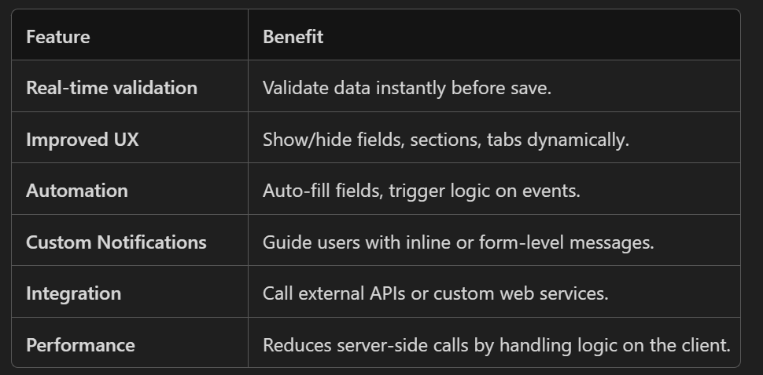

How to debug a JS -

1.Dev tool Ctrl + P -> find the file set the breakpoints
Perform action e.g - onchange of field
This will hit the break points

- Use debugger inside a function

Difference between Synchronus and Asynchronus
31 August 2025
21:18
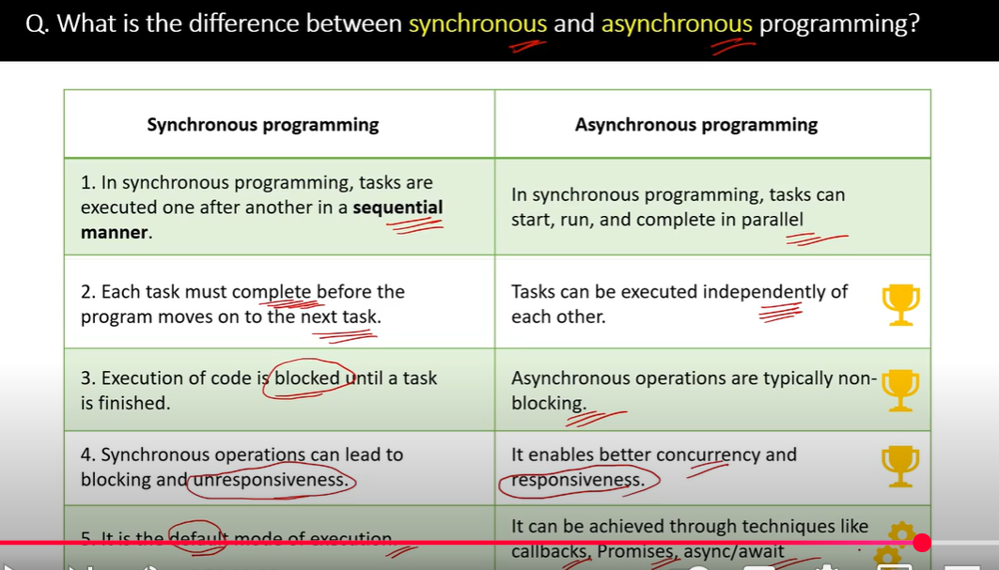

Implementing asynchronus validation
08 September 2025
11:30

async and await are keywords in JavaScript that make working with Promises easier and more readable.
They allow you to write asynchronous code that looks and behaves like synchronous code.
Why use async/await in Dynamics CRM?
In Dynamics 365 CRM, you often need to:

Call the Web API (e.g., Xrm.WebApi.retrieveMultipleRecords)
Wait for the response
Then perform validation or update the form
These operations are asynchronous — they take time and return a Promise. Using async/await lets you handle them cleanly.

For example:
async function validateEmail(executionContext) {
var formContext = executionContext.getFormContext();
var email = formContext.getAttribute("emailaddress1").getValue();
if (!email) return;
try {
// Await the result of the async API call
var exists = await checkEmailExists(email);
if (exists) {
formContext.getControl("emailaddress1").setNotification("This email already exists.", "email_check");
} else {
formContext.getControl("emailaddress1").clearNotification("email_check");
}
} catch (error) {
console.error("Validation error:", error);
}
}
🔧 Helper function: -
function checkEmailExists(email) {
var query = `/contacts?$select=emailaddress1&$filter=emailaddress1 eq '${email}'`;
return Xrm.WebApi.retrieveMultipleRecords("contact", query).then(function (result) {
return result.entities.length > 0;
});
}

  - validateEmail is marked async, so it can use await.
await checkEmailExists(email) pauses execution until the API call completes.

Debugging
31 December 2025
14:21

Step Into (next function call)
- Behavior: Moves the debugger into the next function that’s called on the current line, pausing at the first executable line inside that function.
- Use when: You want to inspect the internals of the function being called—its parameters, local variables, branch logic, etc.
- Example:
C#
// Current line
var total = CalculateTotal(items); // Step Into pauses inside CalculateTotal(...)
Show more lines
- Notes:
  - If multiple function calls exist on the same line, many debuggers will step into the first callable portion, or prompt you to pick (depends on IDE).
  - In some IDEs there’s also Step Into Specific (lets you choose which call to enter if there are multiple on a line).

🟩 Step Over (next function call)
- Behavior: Executes the entire current line, including any function calls on it, without entering those functions; then pauses on the next line in the current function.
- Use when: You trust the called function or don’t need to inspect its internals right now; you’re focused on how the current function progresses.
- Example:
C#
// Current line
var total = CalculateTotal(items); // Step Over runs CalculateTotal(...) fully and stops at the next line here
Show more lines

🟨 Bonus: Step Out
- Behavior: Runs until the current function returns, then pauses at the line after the call in the caller.
- Use when: You accidentally stepped into a function (or you’re done inspecting it) and want to get back out quickly.

Use of Html in msd 365 crm
06 January 2026
15:32

<script>/WebResources/ClientGlobalContext.js.aspx</script> is a special script reference used in Dynamics 365 CRM web resources.

What it does :
  - It loads the Client Global Context JavaScript file provided by Dynamics 365.
  - This file gives your HTML web resource access to the Xrm object (the Dynamics client-side API).
  - Without this script, your HTML page cannot use Xrm.Page, Xrm.WebApi, or other CRM form context functions when embedded in Dynamics.

Why it’s needed:
  - When you create a custom HTML web resource and open it inside Dynamics (e.g., via navigateTo or an iframe on a form), you need the CRM context to:
    - Read form data (Xrm.Page.getAttribute(...) or formContext.getAttribute(...)).
    - Call Web API (Xrm.WebApi.retrieveRecord, Xrm.WebApi.execute).
    - Navigate to records (Xrm.Navigation.navigateTo).
  - This script injects the current CRM session context into your page.
============================================================

  - JavaScript Web Resource (.js)
Purpose: Reusable script files to run inside forms, ribbons, and command bars.
Context: Gets executionContext → formContext in form events, can run inline on entity forms, and is the default for form scripting.
Best for: Field validation, business logic on form load/change/save, ribbon command handlers.
  - HTML Web Resource (.html)
Purpose: Standalone mini-pages (UIs) you can show in dialogs, iframes, dashboards, or subgrids.
Context: Runs as a separate page that can use Xrm (via ClientGlobalContext and hosting), but it doesn’t receive executionContext unless embedded.
Best for: Custom dialogs, wizards, selectors, visualization, or micro-UI that interacts with records via Xrm.WebApi.

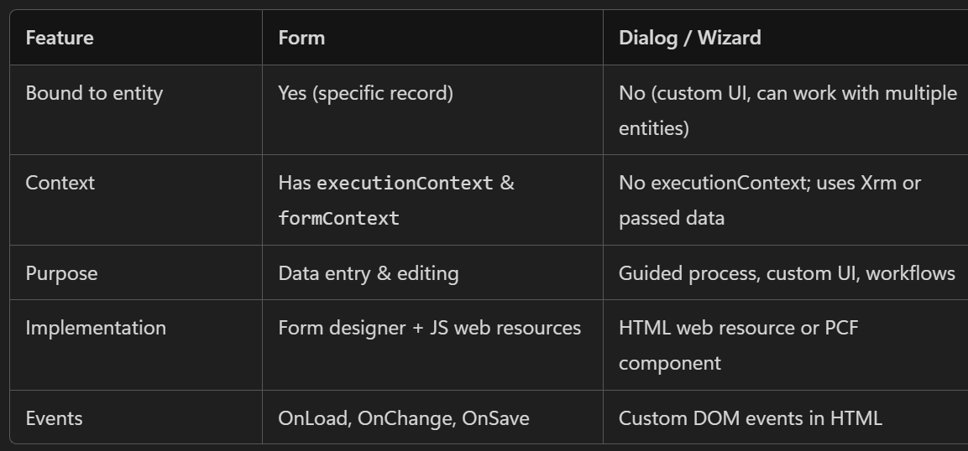

Why js does not need the /WebResources/ClientGlobalContext.js.aspx&lt;/script&gt

  - JavaScript (.js) web resources typically don’t need
/WebResources/ClientGlobalContext.js.aspx
because they run inside the form/page that Dynamics already loaded, where the Xrm object and client context are already available.
  - HTML (.html) web resources often do need it because they are separate pages. If you open them as dialogs or stand-alone web resources, they don’t automatically inherit the app shell’s context, so you include the ClientGlobalContext to make Xrm available inside that page.

JS-Technical Interview Questions
08 September 2025
11:46

Q1 . Can you explain one advantage of using JavaScript in Dynamics 365 CRM ?
Ans:
1. Enhanced User Experience through Real-Time Form Validation and Automation
-->
JavaScript allows you to:

1.Validate data instantly as users enter it (e.g., check required fields, format phone numbers).
2.Automatically show/hide fields, set default values, or lock fields based on user input.
3.Trigger logic on events like on Change, on Load, or on Save — without needing to wait for server-side processing.

Q 2.Can you explain how to create and throw a custom error in JavaScript, and provide an example of when this might be useful in a Dynamics 365 CRM context?
Ans:
- You can define a custom error by extending the built-in Error class:

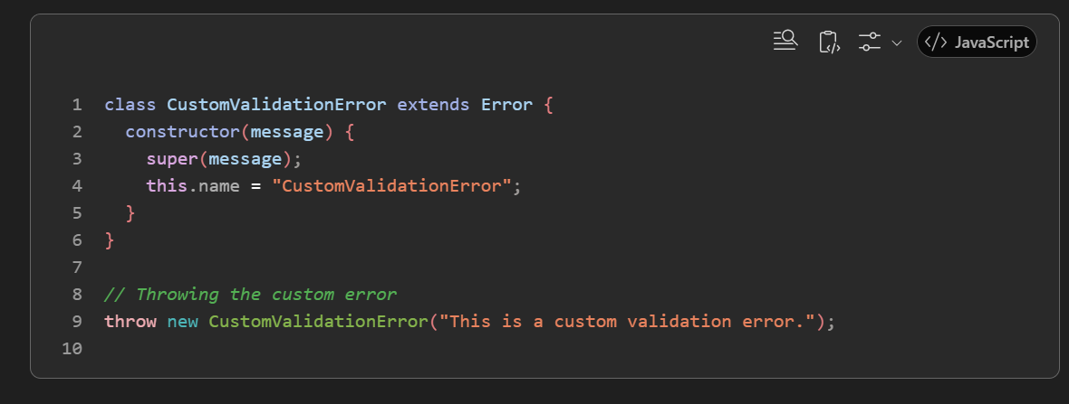
Example scenario :

  - You're writing a JavaScript function for the on Save event of a form. You want to ensure that the "Estimated Revenue" field is not negative. If it is, you want to stop the save and show a meaningful error.

  - 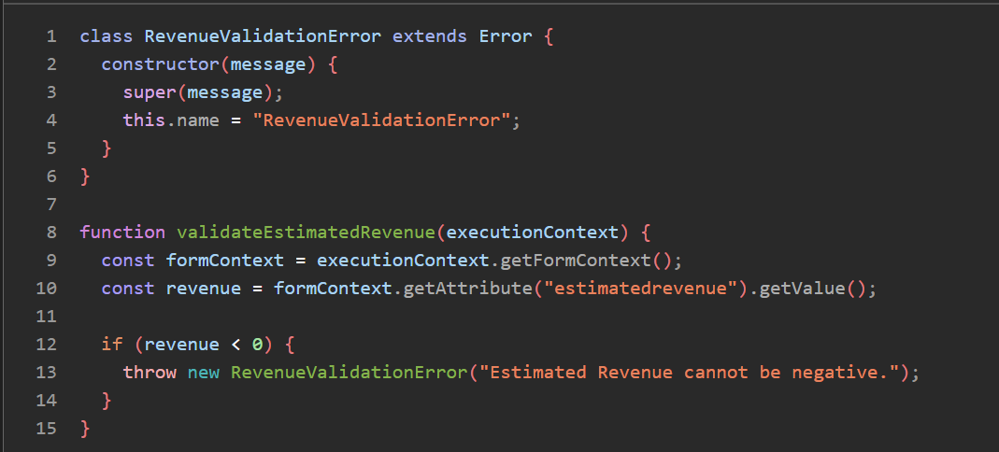

  - The form is prevented from save
  - The user sees a red error bar at the top of the form with the message:
"Estimated Revenue cannot be negative"

Q3. How do you handle errors in JavaScript used within Dynamics 365 CRM?
Ans:
- To handle errors in java script we can use the try-catch-block methods where we write the main logic of the code in the try-block. The error that might occur in try-block will be cached in the catch block by using different exceptions. We can write the custom exceptions as well. Also by using feedback mechanisms like console.log error.
- we can specify the error messages to the users. Also by using browser developer tools we can track the errors that are occurred in the system. Also by using debugging techniques or debugger in the java script code we can also handle the errors in Dynamics CRM.

Q 4. Can you explain how to pass parameters to an on Change event handler in Dynamics 365 CRM JavaScript functions?
Ans -
- use a wrapper function - You can define a wrapper function that calls your actual handler with additional parameters.
- 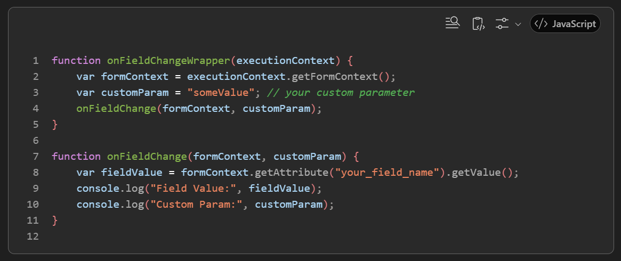
- Use Form Context to Store Parameters
If the parameter is dynamic and can be stored in the form (e.g., in a hidden field or formContext data), you can retrieve it inside your handler.

- Asynchronus validations:

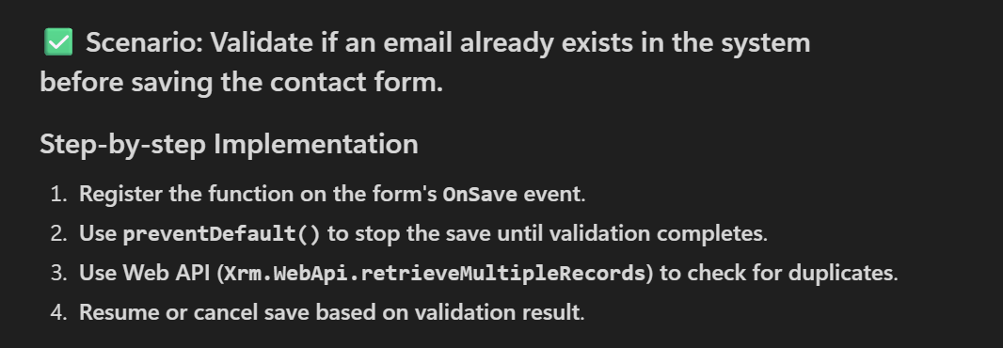
Sample code -

function asyncEmailValidation(executionContext) {
var formContext = executionContext.getFormContext();
var eventArgs = executionContext.getEventArgs();
var email = formContext.getAttribute("emailaddress1").getValue();
if (!email) return;
// Prevent the form from saving until validation is complete
eventArgs.preventDefault();
// Query to check if email already exists
Xrm.WebApi.retrieveMultipleRecords("contact", `?$select=contactid&$filter=emailaddress1 eq '${email}'`).then(
function success(result) {
if (result.entities.length > 0) {
// Email already exists
formContext.ui.setFormNotification("This email already exists in the system.", "ERROR", "email_check");
} else {
// Email is unique, manually save the form
formContext.data.save().then(
function () {
console.log("Form saved successfully.");
},
function (error) {
console.error("Error saving form: " + error.message);
}
);
}
},
function (error) {
console.error("Error during email validation: " + error.message);
}
);
}

- How can you trigger a form event using JavaScript in Dynamics 365 CRM?
Ans -
1. Triggering a Field Change Event via Form Editor-
- You can manually call this function like this

- 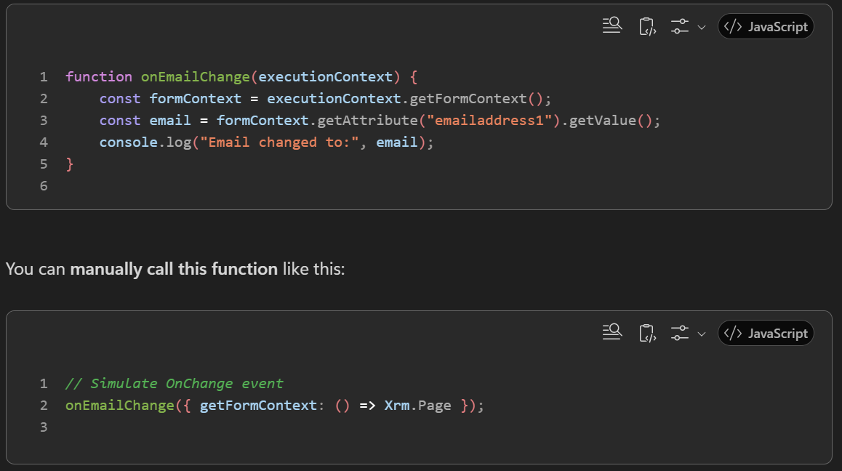

Custom api
08 February 2026
21:36

- Create the custom api
unique name - start with solution prefix
Binding type - global (not bind to any entity )

- Create the custom api request parameters
- add the data type for parameter
Here 3 parameters are passed as input parameters
- Field name
- Target entity name
- Target entity id

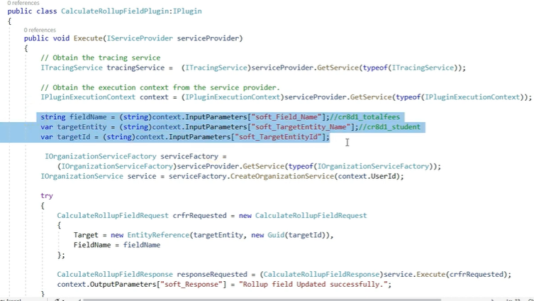

Create a custom api output parameter -response parameters

Register the plugon in PRT

Add the plugin in custom api

Now
Setting - customizations - developer resource - service root url - this is the web api url we can call web api

Call this web api - using the postman or power automate
-call the url with post message

The plugin will be called it will implement the logic

What is Web API in Dynamics 365 / Dataverse?
Web API = RESTful service provided by Dataverse that allows you to create, read, update, delete (CRUD) and query CRM data using HTTP requests (GET, POST, PATCH, DELETE).

Web Api
09 June 2025
11:11
  - Difference between Xrm Web Api and XmlHttpRequest
Ans :
XRM:
  - The ability to extend the CRM (Customer Relationship Management) platform to manage more than just customer relationships
  - It allows organizations to manage various business processes.
  - XRM Web Api is designed to interact directly with dataverse - not external http endpoints like power automates http trigger.

Difference :

1. Xrm.WebApi

  - A modern JavaScript API provided by Dynamics 365 to interact with the Dataverse (formerly Common Data Service) using Web API.
  - Simplifies CRUD operations (Create, Retrieve, Update, Delete).

What is .then()?
.then() is a method used with Promises in JavaScript. It defines what should happen after an asynchronous operation (like a web API call) completes successfully.

e.g : XRM.WebApi.Retrieverecord("account","guid").then(function success(result){
console.log("Account Name: " + result.name);

});

  - Xrm.WebApi.retrieveRecord(...) returns a Promise.
  - That Promise represents a future result — in this case, the account record.
  - .then() is used to handle the result once the operation is done.

  - it is always Asynchronous

a.There is no way to make a synchronous call, even if you are going to use chaining or await keyword it still going to be an asynchronous call.

  - XMLHtttpRequest

  - A native JavaScript object for making HTTP requests.
  - Can be used for both synchronous and asynchronous calls.

  - Synchronous

var req = new XMLHttpRequest();
req.open("GET", Xrm.Page.context.getClientUrl() + "/api/data/v9.1/accounts", false); //false- synchronus

2. Asynchronous

var req = new XMLHttpRequest();
req.open("GET", Xrm.Page.context.getClientUrl() + "/api/data/v9.1/accounts", true);
//True- asynchronus.

So, passing true parameter is going to make asynchronous call while passing it false is going to make a Synchronous call.

Summary :

  - Use Xrm.WebApi when working with Dataverse data inside Dynamics 365.
  - Use XMLHttpRequest (or fetch()) when calling external APIs like Power Automate HTTP triggers or third-party services.

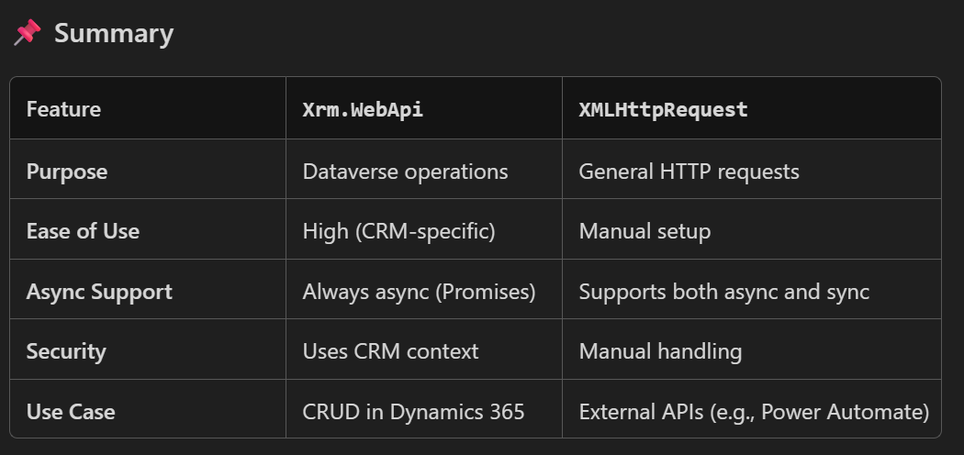

Q 2 . latest version in msd 365 crm
  - Dynamics 365 version 9.0

Q 3. Editable Subgrid
  - An editable grid in Microsoft Dynamics 365 CRM allows users to edit records directly within a grid view — either on a form (subgrid) or in a main view — without opening each record individually.
  - This improves efficiency and user experience, especially for bulk data entry or quick updates.

  - 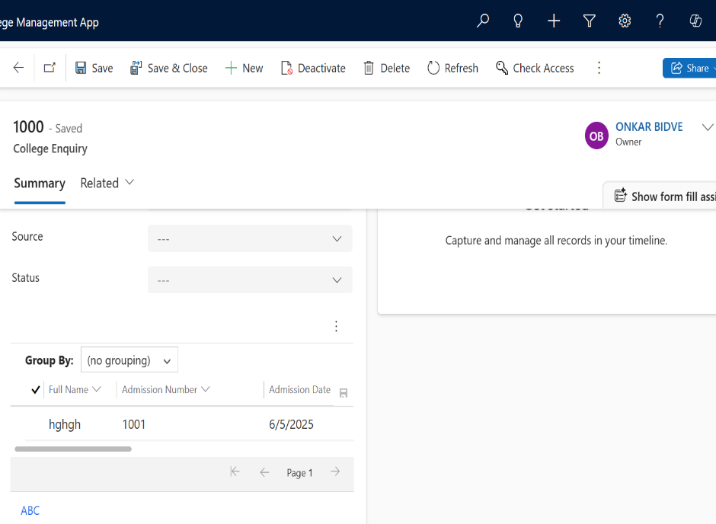

Q 4 How to call plugin using the js?

Custom Api -
Global (Unbound)
✔ Operation does NOT apply to any specific table
✔ Called directly from Web API like a global action
✔ No Target parameter is automatically generated
Entity (Bound to a single record)
✔ The API is bound to a single row of a table
✔ Dataverse automatically adds a Target parameter (EntityReference)
✔ API is invoked on a specific record via Web API
EntityCollection (Bound to table collection)
✔ API applies to the entire table or a collection of records
✔ No automatic Target parameter
✔ Called using table set binding

Best Practises
1. JS Naming convention
Unique function prefix - Define each of your functions by using the standard syntax with a consistent name that includes a unique naming convention, as shown in the following example.

JavaScript
function MyUniqueName_performMyAction()
{
// Code to perform your action.
}
Libraries with namespaces - Associate each of your functions with a script object to create a namespace to use when you call your functions, as shown in the following example.

JavaScript
//If the MyUniqueName namespace object isn’t defined, create it.
if (typeof (MyUniqueName) == "undefined")
{ MyUniqueName = {}; }
// Create Namespace container for functions in this library;
MyUniqueName.MyFunctions = {
performMyAction: function(){
// Code to perform your action.
//Call another function in your library
this.anotherAction();
},
anotherAction: function(){
// Code in another function
}
};
When you use your function, specify the full name, as shown in the following example.

JavaScript
MyUniqueName.MyFunctions.performMyAction()

If you call a function within another function in the same namespace, you can use the this keyword as a shortcut to the object that contains both functions. However, if you use your function as an event handler, the this keyword will refer to the object on which the event is occurring

